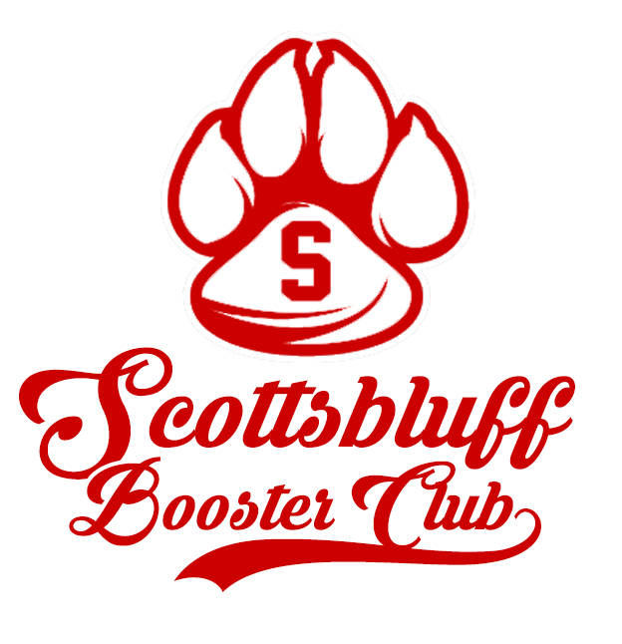
Greetings SHS Students, Parents and Alumni!

On behalf of the Booster Club, I would like to welcome you to another great year of activities at Scottsbluff High School. As a Club, we’re excited to continue our support for the many events that take place within the school system while also promoting good sportsmanship, recognizing academic achievement and encouraging community involvement.

The Fall Kickoff Picnic is scheduled for August 5th at Scottsbluff High School and is scheduled to begin following the Bearcat Pride Plaza dedication at 5:30pm. I would like to invite you to attend this event as we welcome a new school year. You will have the opportunity to purchase your 2018-2019 Activities Pass as well as signing up to be a Bearcat Booster Club supporter. The SHS school store will be open during the event with a number of new Bearcat merchandise items for sale. Being successful in reaching our fundraising goals wouldn’t happen without your support along with the contributions that we receive from local businesses and sponsors. As many of you know, we launched the new scoreboard project last summer and it was a huge success. The graphic arts and media career academy students did a great job with developing content throughout the year with the help of Mr. Wayne Lemoine, excited to see what they come up with for this year. The Booster Club was also able to help support a number of activities and clubs throughout the school year. I would like to extend my thanks to you as students and parents, as well as to our business community for all that you do for SHS.

We’re fortunate to have a great group of supporters who have become members of the Booster Club and who have volunteered to serve in various roles. We meet once per month at the high school and I INVITE YOU to become a member of a club that for over 30 years has helped to provide funds for track, cross country, drill team, basketball, wrestling, yearbook, band, choir, speech team, FCCLA, HOSA, prom, Chenille Letters for Letter winners, scholarships, Booster Awards for outstanding students in each activity and sport, and many more. Look for our tailgate picnics before home football games and our Spirit Wear sales as ways for you to show your Bearcat Pride. We value your participation, input and ideas and hope that you’ll accept the invitation to join us. Membership forms will be available at the Fall Kickoff Picnic and throughout the year at any of our Booster Club functions.

Please contact me at kriewaj@charter.net with any questions or thoughts that you would like to share, and I thank you for your consideration.

Good luck to all, and GO BEARCATS !

Jeff Kriewald SHS Booster Club
President

MEMBERSHIP FORM
Scottsbluff Booster Club

Being a supporter of the Booster Club isn’t limited to those who have a child at the High School, it’s for anyone who has a genuine interest in providing resources for the benefit of students and student-athletes as they participate in activities at Scottsbluff. We hope that you have that interest and a belief in what we do. We also recognize that people have many choices on how they use their money. Your investment in our efforts would be highly valued and greatly appreciated.

To highlight the importance, we’ve established the following levels to recognize the generosity of our supporters and invite you to come shopping at the school store. . . .

Cat Pack $25

Red $50

Receive a Booster Club Bearcat License Plate Cover

White $100

Receive a $15 Gift Certificate for Booster Club Spiritwear

Bearcat $250

Receive a $50 Gift Certificate for Booster Club Spiritwear

Champions $500 and Up

Receive a $125 Gift Certificate for Booster Club Spiritwear

Name(s) ________________________________________________________________
Student Name(s) __________________________________________________________
Address__________________________________________________________________
City, State, Zip ____________________________________________________________
Phone__________________________ E-Mail___________________________________

MEMBERSHIP LEVEL (circle one): Cat Pack Red White Bearcat Champions

Please mark any activity that you would be interested in helping with ……
___ Football Tailgate ___ Spirit Wear Committee ___ Booster Club Marketing
___ Spirit Wear Sales - Football ___ Fall Kick Off Picnic ___ Bearcat Vision/Scoreboards
___ Sprit Wear Sales - Basketball ___ Putt for the Paw Golf Tournament ___ Sprit Wear Sales – Conferences
___ Sprit Wear Sales – Volleyball ___ Sprit Wear Sales – Elementary Track

Please return this form today to the Activities Office at SHS with your tax deductible gift payable to the Scottsbluff Booster Club.

THANK YOU !

____________________________________________________________________________________________________________________________________________________

